NanoEthicsBank Website Specification

1.0 General

1.1. Overview
The NanoEthicsBank is a database conceived as a resource for researchers, scholars, students, and the general public who are interested in the social and ethical implications of nanotechnology. Items in the database include normative documents, such as guidelines for safety in the workplace, and descriptive materials, such as analysis of the U.S. government’s capacity for oversight and studies of the media coverage of nanotechnology. For more resources on nanotechnology research and development, please see our collection of further resources that includes links to databases of research projects on environmental health and safety implications of nanotechnology, and links to other nano institutes and organizations.

1.2. Background
New material is added to the NanoEthicsBank as it becomes published or available online. Records contained in the database include all relevant citation information, an abstract, and links to material freely available on the World Wide Web. The full text of publicly available documents, such as government reports, is included in the NEB

1.3. Current Situation
The URL for the website is: http://ethics.iit.edu/NanoEthicsBank/

- Specification

2.1. Overview

Nanoethics website is built on PHP, HTML,JavaScript and SQL. We have created our own CSS style sheet for this website.
The PHP script queries the database and displays the information on the page. The details about the database are mentioned at the end of the document.

2.2. Design

i. http://ethics.iit.edu/NanoEthicsBank/index.php

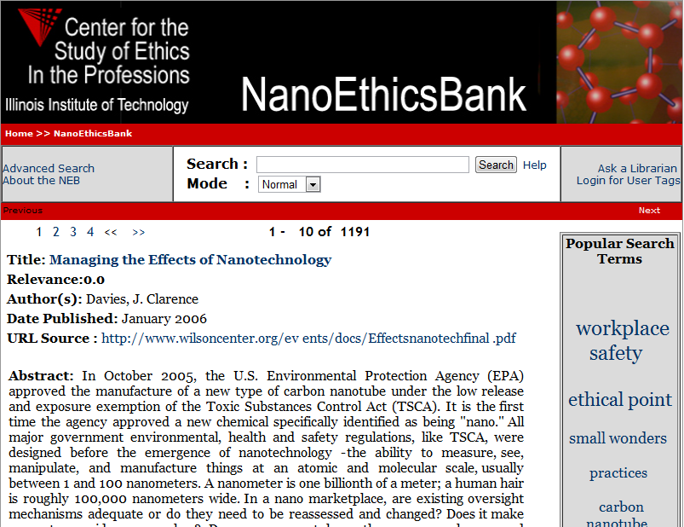

Filename: index.php – Home Page
Tables: bank, tagclouds, details
Files included: nebsearchform.php, Footer.php.
Description:
- A tagcloud table is generated as and when the search words are hit. According to the frequency of search words, top 25 of them appear along the right hand side as popular searches.
- Nebsearchform.php is used to display the search form along with the advanced search options. The search could be performed in normal or Boolean mode. The contents in the page are queried from the ‘book’ table and displayed according to the descending order of the relevance.
- The ‘details’ table contains the information about the various attributes pertaining the articles.

ii. http://ethics.iit.edu/NanoEthicsBank/asearch.php

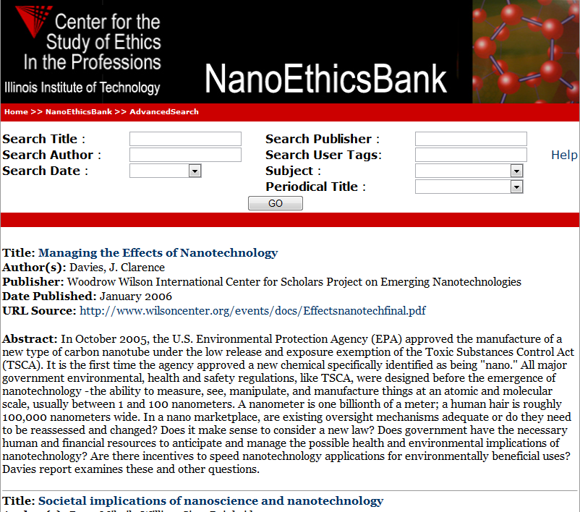

Filename: asearch.php – Advanced Search
Tables: bank, details
Files included: Footer.php
Description: Whenever author, title, publisher date, Periodical date,user tags etc or the combination of these is queried in the tables details and book together and corresponding articles are displayed.

2.3. Integration

Some pages have same functionality as that of CSEP website, hence same modules are shared by both the websites.
The source code of the NanoEthicsBank is on the hawk server, along with the CSEP website source code.

2.4. Administration

The admin module lets us add/update the contents of various articles.
We can also add/update user information like name, password etc.

- Database

Serverhost: myst-my-p.cns.iit.edu
Username: csep
Password: ec1976!
Db: nanoethicsbank

Though the database might have many tables mainly tables: bank, details, tagclouds, user (for login details) get used.
Database backup is taken every alternate day using SQL Query Browser. It generates a .sql file.

